Section 1 Course Introduction

1. Practice Activities, Homework assignments/ exercise, Hands-on practice
2. Coding Questions.
3. Solution Source Code, Source Code.

Section 3 Setting Up Your Development

1. Tomcat installation as window service with tomcat installer (a msi file).
2. Eclipse Environment.
3. Server.

*Section 4 Spring Inversion of Control - XML Configuration*

1. Programming to Interface.
2. Inversion of Control, Dependency Injection.
3. 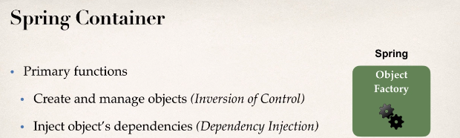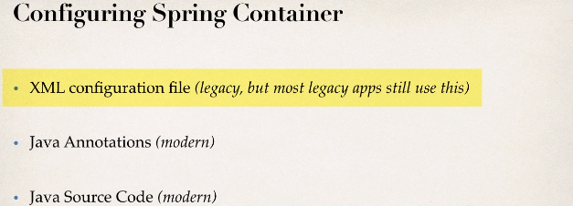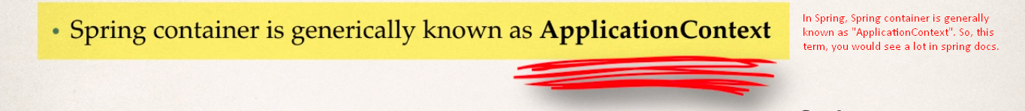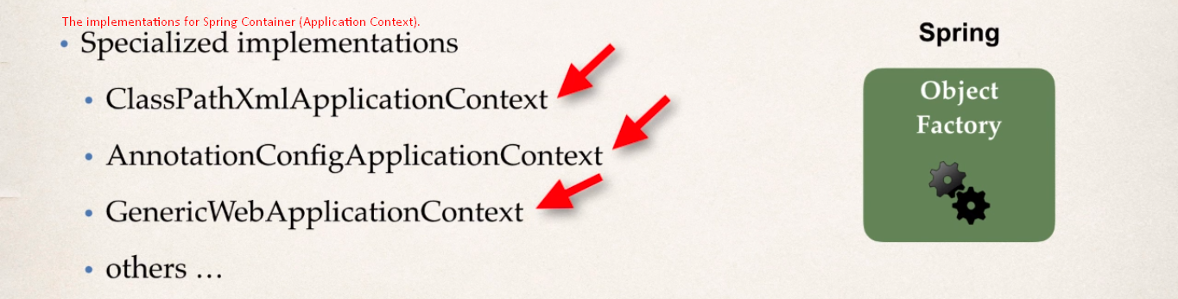
4. Java Beans, Spring Bean, Java Object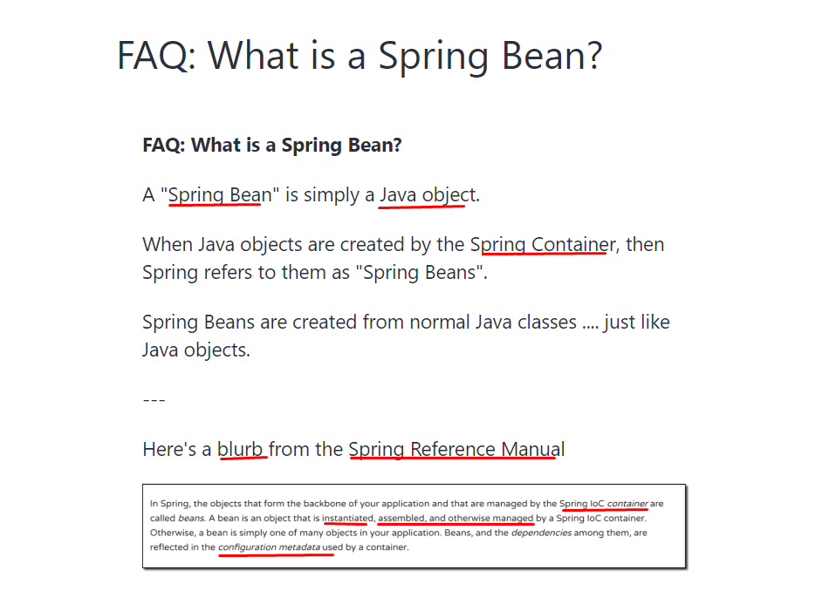
5. Logging Levels, red logging messages at INFO Level,
6. Spring Development Team
7. 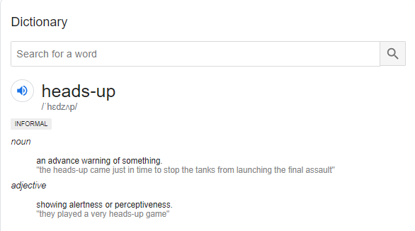
8. Constructor Injection, Setter Injection.
9. Properties File, Spring Config File
10. <context:property-placeholder, location=””
    1. value=”${propertyName}”
11. <bean scope=”singletone”
12. 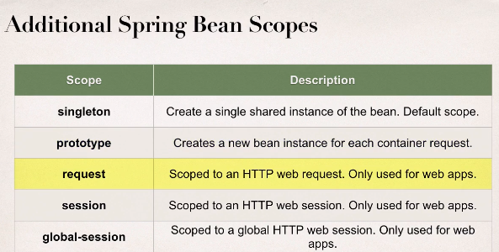
13. 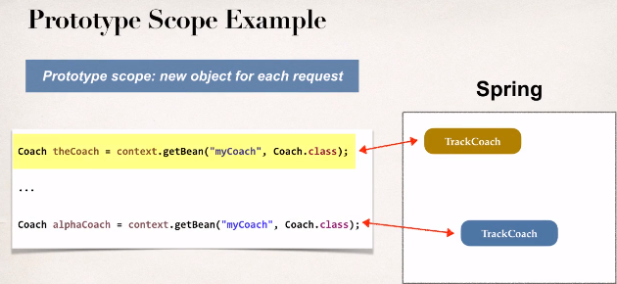
14. <bean **init-method**=”anyMethodName”
15. <bean **destroy-method**=”anyMethodName”

Section 7 Spring Configuration with Java Annotations - Inversion of Co

1. Java Annotation, Labels/markers, Meta Data, Compile/Run time.
2. Component classes, Component Scanning, @Component.
3. <context:component-scan base-package=”packageName” />

Section 8 Spring Configuration with Java Annotations - Dependency Inj

1. Autowire, Autowiring Injection Types
   1. Constructor Injection, b. Setter Injection, c. Field Injection.
2. @Qualifier:   
   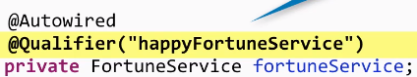

Section 9: Spring Configuration with Java Annotations - Bean Scopes an

1. Bean scope with Annotation. Singleton (default), Spring Container,
2. **Spring Configuration with Java Code 🡺 Java Config**
3. **3ways to Configure:** Full XML config, XML component scan, Java Configuration Class.
4. @Configuration, @ComponenetScan, @Bean, AnnotationConfigApplicationContext ©

Section 11 - Spring MVC - Building Spring Web Apps

1. Spring MVC, MVC Design Pattern, Request Flow, Front Controller, DispatcherServlet, Model, View Template,
2. **Components of a Spring MVC Application**:
   1. **Web Pages** + **Beans** + **Spring Configuration Files**
3. **Spring MVC Front Controller**: Known as **DispatcherServlet,** delegates request to controller, **Controller**, **Model** database or web service.
4. **View Template: Thymeleaf, Groovy, Velocity, Freemarker**.
5. Spring MVC Configuration, DispatcherServlet, <mvc:annotation-driven />

**Section 12 - Spring MVC - Creating Controllers and Views**

1. Developing Spring Controllers & Views
2. Request mapping for a path
3. Request Path, Web Browser, Front Controller, Controller, Model, View Template
4. @Controller (inherited from @Component), @RequestMapping, InternalResourceViewResolver, prefix, suffix
5. ${**param**.parameterName}
6. Spring Model: Container for app data. Model Java Type
7. War: Web Archive File is Web application Archive file

Section 13 - Spring MVC - Request Params and Request Mappings

1. Reading HTML form data with @RequestParam
2. @RequestMapping(“/hello”): At controller level (Parent Mapping) as top directory to group request mappings or to conflict.

Section 14 - Spring MVC - Form Tags and Data Binding

1. Spring MVC Form Tags (Configurable, Resuable), Data Binding.
2. Web Page Structure: JSP Page with special Spring MVC Form tags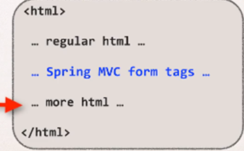
3. Spring MVC Form Tag – Text Field.
4. Model attribute, Data Binding, Setting up HTML Form – Data Binding, When form is loaded … fields are populated.
5. <form:select items=”mapHere”>
6. 